**Exercise 1: Implementing the Singleton Pattern**

**Scenario:**

You need to ensure that a logging utility class in your application has only one instance throughout the application lifecycle to ensure consistent logging.

**Steps:**

1. **Create a New Java Project:**
   * Create a new Java project named **SingletonPatternExample**.
2. **Define a Singleton Class:**
   * Create a class named Logger that has a private static instance of itself.
   * Ensure the constructor of Logger is private.
   * Provide a public static method to get the instance of the Logger class.
3. **Implement the Singleton Pattern:**
   * Write code to ensure that the Logger class follows the Singleton design pattern.
4. **Test the Singleton Implementation:**
   * Create a test class to verify that only one instance of Logger is created and used across the application.

**IMPLEMENTATION IN ECLIPSE :**

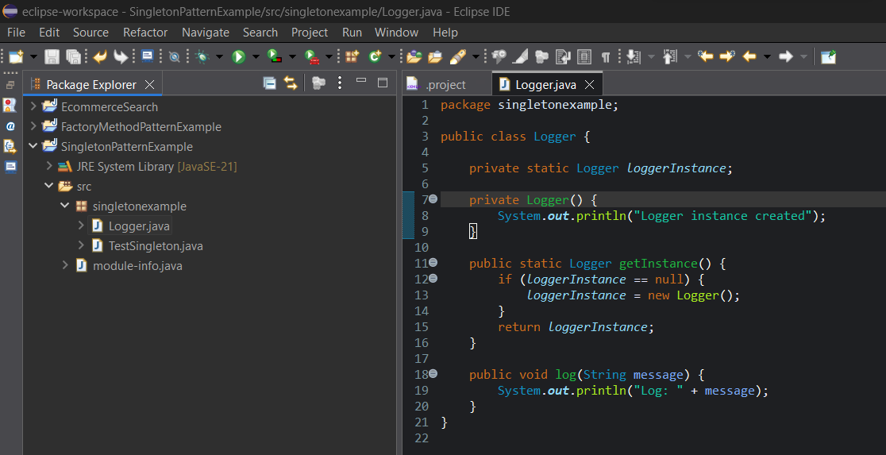

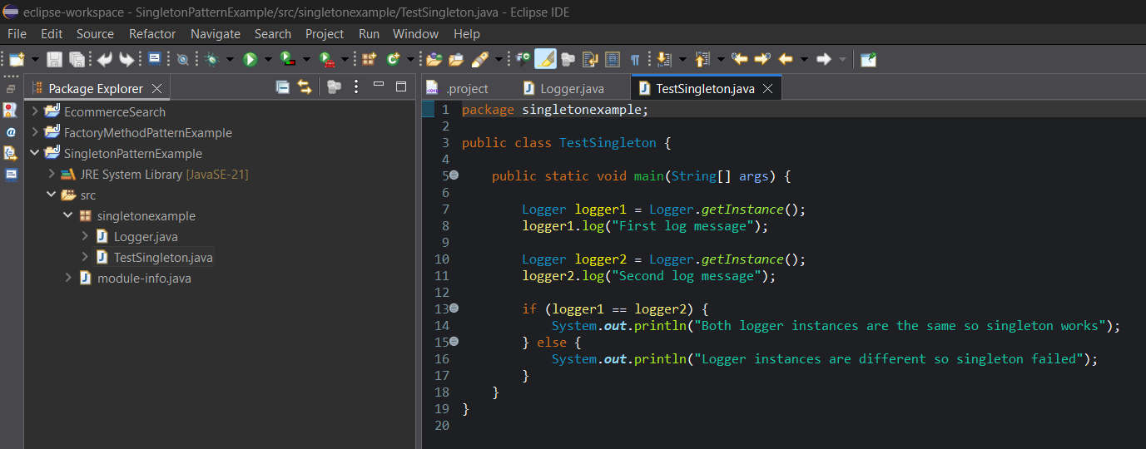

**OUTPUT :**

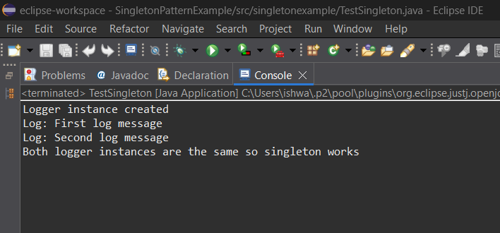

**PROGRAM :**

package singletonexample;

public class Logger {

private static Logger *loggerInstance*;

private Logger() {

System.*out*.println("Logger instance created");

}

public static Logger getInstance() {

if (*loggerInstance* == null) {

*loggerInstance* = new Logger();

}

return *loggerInstance*;

}

public void log(String message) {

System.*out*.println("Log: " + message);

}

}

package singletonexample;

public class TestSingleton {

public static void main(String[] args) {

Logger logger1 = Logger.*getInstance*();

logger1.log("First log message");

Logger logger2 = Logger.*getInstance*();

logger2.log("Second log message");

if (logger1 == logger2) {

System.***out***.println("Both logger instances are the same so singleton works");

} else {

System.***out***.println("Logger instances are different so singleton failed");

}

}

}

**OUTPUT :**

